P1#yIS1

FAKULTI TEKNOLOGI MAKLUMAT DAN KOMUNIKASI

BITI3533 ARTIFICIAL INTELLIGENCE PROJECT MANAGEMENT

PROJECT REPORT

TITLE: AUTOMOTIVE VEHICLES ENGINE HEALTH PREDICTION

LECTURER: DR BURHANUDDIN BIN MOHD ABOOBAIDER

GROUP MEMBERS

|  |  |  |
| --- | --- | --- |
| NAME | MATRIC NO | SECTION/GROUP |
| SIM WENG JIN | B032110376 | BITI S1G2 |
| ANG WEI KANG | B032110301 | BITI S1G2 |
| LUM FU YUAN | B032110251 | BITI S1G2 |
| TEH XIAO THONG | B032110141 | BITI S1G2 |

**TABLE OF CONTENTS**

1. Introduction
   1. Background
   2. Case Study
2. Software Detail
3. AIPM Detail
   1. Initiating Processes
   2. Planning Processes
   3. Executing processes
   4. Monitoring and controlling processes
   5. Closing processes
4. Flow, Algorithm and Problem Solving
5. Project Implementation and Output
6. Conclusion
7. References
8. Appendices
9. **INTRODUCTION**
   1. **Background**

Predictive repair in the car business is getting a lot of attention because it provides an active way to take care of vehicle health. Normally, car fixing used to depend on planned or emergency methods, which could cause problems with the vehicle, increase in waiting time and costing a lot in repairs. By using machine learning models, predictive maintenance has become a good way to solve these problems. This is possible because of improvements in sensor technology and data analysis.

Modern cars come with many sensors that always check different things related to engine performance. These measurements make a lot of data, giving useful knowledge about the health state of car parts. Neural networks and other machine learning models have shown they can find patterns in big datasets, predict problems correctly, which means that they work well on complex data sets. In this project, by analyzing the real-time sensor data, it is possible to predict when maintenance or repairs need to be done, to optimize resource allocation and minimize downtime.

* 1. **Case Study**

The main objective of this project is to develop a robust model for automotive engine health prediction using supervised learning methodologies. The model uses feedforward neural network with the multilayer perceptron (MLP) architecture, a backpropagation algorithm for training. The dataset contains critical measurements such as engine revolutions per minute (RPM), lubricating oil pressure and temperature, fuel pressure, and coolant pressure and temperature. Before training, an incredibility precise preprocessing step that includes normalizing and scaling all input features is performed for maximum model efficiency. 70% of the dataset represents a training set to be used in assessing how well the model can predict engine conditions while 30% is designated as testing data. The anticipated advantages of this strategy include pre-emptively identifying potential engine problems, continuous real time monitoring and gaining a deeper understanding into how sensor measurements affect the state of an engine’s health. Successful implementation of this predictive maintenance model will also result in considerable cost savings, better failure prevention levels, reduced downtime, and improved safety around the engine.

1. **Software Detail**

Purpose:

1. Predictive Maintenance:

The software is intended to predict potential problems or failures in vehicle parts using sensor data analysis. It leads to proactive strategies for preventive maintenance in order not only to avoid breakdowns but also reduce repair costs.

Key Features:

1. Data Acquisition:

It collects and aggregates sensor data from different vehicle components, such as engine RPM, oil pressure, temperature etc., of various systems.

1. Preprocessing and Cleaning:

Prepares the data for analysis by performing preprocessing steps such as cleaning, normalization, outlier detection and handling missing values.

1. Machine Learning Models:

It uses neural networks or other machine learning algorithms performing the analysis of sensor data, pattern identification and predicting potential faults where maintenance is required.

1. Alerts and Notifications:

Creating real-time alerts or notifications for vehicle owners of maintenance teams regarding potential hazards or requirements in vehicles.

1. Dashboard and Reporting:

Offers an easy-to-use dashboard showing engine health metrics, predictive results and comprehensive reports suggesting maintenance recommendations.

1. Integration Capabilities:

Enables synchronization with current vehicle administration systems or databases to view past maintenance records, and possibly other data particularly about the vehicles.

1. Scalability and Performance:

Ensures efficient handling of high volumes of sensor data and accurate prediction issues for various vehicle models.

Software Components:

1. Data Acquisition Module:

Gets sensor information from vehicles, stores them in a structured format and prepares it for analysis.

1. Data Preprocessing Module:

Cleaning, preprocessing, and transforming raw sensor data, which eliminates noise and inconsistencies.

1. Machine Learning Model Module:

Uses neural networks or other ML models that are trained using historical data and real-time information to predict potential faults.

1. Alerts and Notifications Module:

Provides warnings or alarms to vehicle owners or maintenance crews according to their probable requirements for maintenance.

1. Dashboard and Reporting Module:

Offers a user interface where engine health metrics, predictions and detailed reports can be visualized.

Technologies and Tools:

1. Programming Languages:

Data analysis (R), machine learning model development, and backend logic.

1. Data Processing Libraries:

Data manipulation, preprocessing and feature engineering using pandas and NumPy.

1. Backend Frameworks:

Constructing RESTful APIS and server-side logic handling Flask, FastAPI or Django.

1. Database:

Storing sensor data and historical records using PostgreSQL, Firebase, MongoDB or SQLite.

1. Deployment:

Using Docker for containerization, Kubernetes for orchestration and cloud platforms such as AWS, Azure or GCP to deploy.

User Interaction:

1. User Interface (UI):

Offers a user-friendly dashboard for vehicle owners or maintenance crews to monitor the health of an engine, alerts, and reports.

API Endpoints:

It supports interaction with the software through APIs, meaning that it can be integrated with other systems or apps.

Security and Privacy:

1. Data Encryption:

Ensures the confidentiality of sensitive data transmission and storage by encryption.

1. Access Control:

Implements user authentication and authorization mechanisms to control access to sensitive information.

Maintenance and Updates:

1. Support and Maintenance:

Offers continuous technical support and maintenance to make sure the software functions effectively and efficiently.

Documentation and Training:

1. User Manuals and Guides:

Include comprehensive documentation and user guides on how users understand software functionalities.

Training Sessions:

It provides training sessions or tutorials for users to help them efficiently operate the software features.

Compliance and Regulations:

1. Adherence to Standards:

Ensures adherence to industry standards and guidelines concerning data protection, vehicle maintenance.

1. **AIPM Detail**
   1. **Initiating Processes**

Project Objectives Definition:

First, a client should define and formulate key project objectives as well as the envisioned results it wants to achieve. The purpose, scope and anticipated benefits should be well understood in the predictive maintenance model. Also, it includes defining concrete and quantified objectives like an accurate forecast of engine health based on sensor data to facilitate preventive maintenance.

Business Case and Project Charter:

Creating a solid business case and project charter is literally translating it into the document officially sanctioned for the project. The contents of this document are the project’s goals, objectives, stakeholders involved in it, timelines for completion of tasks within the projects and what will be derived as a business value. It is a basic document that provides strategic guide and ensures the project targets organizational goals set as well as stakeholder expectations.

|  |
| --- |
| **TSLA Project Charter**  **Project Name:** Automotive Vehicles Engine Health Prediction  **Project Description:** A system that predicts potential problems or failures in vehicle parts using sensor data analysis and artificial intelligence.  **Business Case:** Increasing sales by 40% for this quarter.  **Project Deliverables:** An AI software implement with car sensor.  **Project Benefits:** Boosted reputation.  **Project Risks:** This is the first project of our company that needed to be implemented into a sensor for real-time detection.  **Project Budget:** Not to exceed RM 2,000,000. |

**Table 3.1.1 Project Charter**

Stakeholder Identification and Analysis:

Identification and analysis of involved stakeholders or those that are impacted by the project is a must. This is the process of identifying key stakeholders, departments or external parties who have a vested interest in successful project outcomes such as individual persons department vehicle owners’ maintenance teams’ industry experts. An understanding of their expectations, requirements and concerns is important in ensuring the project goals are met according to what stakeholders need.

|  |  |
| --- | --- |
| **Types** | **Name** |
| 1. Customer | Yuan Brothers Auto Accessories Service |
| 1. Project Leader | Sim Weng Jin |
| 1. Project Assistant | Lum Fu Yuan |
| 1. Resource Managers | Teh Xiao Thong |
|  | Ang Wei Kang |
| 1. Project Teams | TSLA |

**Table 3.1.2 Stakeholders Analysis**

Risk Assessment and Mitigation Planning:

Identifying potential risks and uncertainties that could influence the success of a project is an important stage. This should be done through a thorough risk assessment that will help anticipate and prepare for challenges in advance. Mitigation strategies and contingency plans are developed with the aim of minimizing negative effects of identified risks on project progression and its outcomes.

Project Kickoff Meeting:

Convening a project kickoff meeting involving key stakeholders, project team members, and relevant personnel is a vital step. This meeting serves to communicate project objectives, roles, responsibilities, timelines, and expectations. It sets the tone for collaboration, establishes a shared vision, and fosters a sense of ownership and commitment among team members.

* 1. **Planning Processes**

Scope Definition and Requirement Gathering:

The Planning Processes start with a detailed analysis and formulation of the project scope. This entails elucidating the specific functionalities, features, and objectives of a predictive maintenance model. It also encompasses the identification of specific requirements, defining user needs and identifying which functionalities are expected from the model.

Work Breakdown Structure (WBS) Creation:

It is important to break down the project deliverables into pieces that can be managed and well structured. The WBS is a hierarchical organization of tasks, sub-tasks and activities in order to enable easier management as well as resource allocation and tracking progress during the lifecycle of the project.

Work Breakdown Structure (WBS):

|  |  |  |  |
| --- | --- | --- | --- |
| **Task** | **Start Date** | **End Date** | **Duration (Days)** |
| **Initiating** | **01-6** | **11-6** | **11** |
| Project Charter | 01-6 | 03-6 | 3 |
| Project Charter Revisions | 03-6 | 04-6 | 2 |
| Research | 07-6 | 11-6 | 5 |
| Projections | 08-6 | 11-6 | 4 |
| Discuss with Stakeholders | 09-6 | 11-6 | 3 |
| Guidelines | 10-6 | 11-6 | 2 |
| **Planning** | **14-6** | **18-6** | **5** |
| Project Initiation | 14-6 | 15-6 | 2 |
| Scope and Goal Setting | 15-6 | 18-6 | 4 |
| Budget Estimation | 16-6 | 18-6 | 3 |
| Communication Plan | 17-6 | 18-6 | 2 |
| Risk Management | 17-6 | 18-6 | 2 |
| **Implement** | **21-6** | **02-7** | **12** |
| Monitoring | 21-6 | 02-7 | 12 |
| Implementation | 21-6 | 07-7 | 17 |
| Status and Tracking | 23-6 | 02-7 | 10 |
| KPI | 27-6 | 01-7 | 5 |
| Error Correction | 28-6 | 08-7 | 11 |
| Forecast | 29-6 | 30-7 | 2 |
| Project Updates | 01-7 | 02-7 | 2 |
| **Project Closing** | **05-7** | **09-7** | **5** |
| Performance | 05-7 | 07-7 | 3 |
| Closing | 08-7 | 09-7 | 2 |

**Table 3.1.3 Work Breakdown Structure**

Task Scheduling and Timeline Establishment:

A comprehensive Project schedule with clearly defined timelines and milestones must be developed. This is the phase where they prepare a project timeline in terms of Gantt charts or similar tools. Task dependencies, critical paths and estimated durations for each activity are identified to ensure a realistic project timeline that can be achieved.

Gantt Chart of the Project:

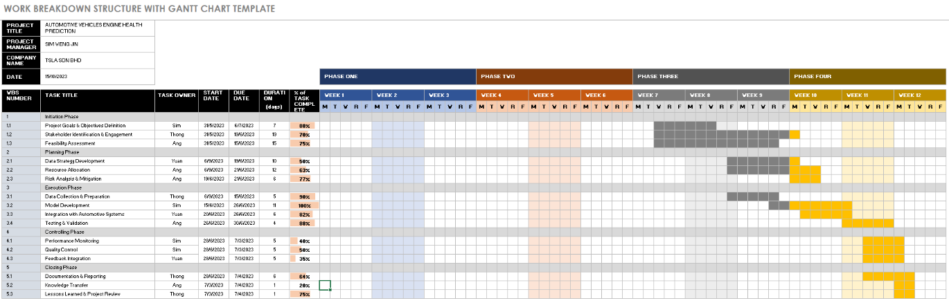

**Figure 3.1.1 Gantt Chart of the Project**

Resource Planning and Allocation:

This step entails smart distribution of the identified resources gained in Initiating Processes phase. It involves assigning roles and responsibilities to team members, defining what they need to do or deliver, ensuring that they have the necessary tools and support in order for them to successfully complete their tasks. Resources should be allocated correctly to prevent bottlenecks and optimize productiveness.

Risk Management and Contingency Planning:

Critical for the Planning Processes is refining of risk assessment conducted during Initiating processes phase. Here elaborate risk management plans are developed which involve strategies for mitigation of risks contingency plan and response measures in case any unpredicted challenges occur during the execution phase.

SWOT Analysis:

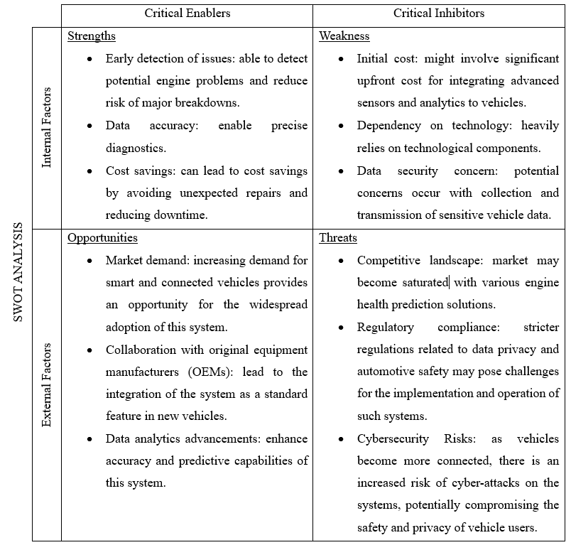

**Table 3.1.4 SWOT Analysis**

Budgeting and Cost Estimation:

A well-rounded budget plan requires the estimation of costs related to project components including technology, human resources, tools, and infrastructure. Correct costing estimates contribute to effective resource allocation, budget control and the capability of a project staying within its financial limits.

P371#yIS1

**Table 3.1.5 Automotive Vehicles Engine Health Prediction Project Cost Estimate**

P374#yIS1

**Table 3.1.6 Automotive Vehicles Engine Health Prediction Project Development Estimate**

Quality Assurance and Standards Setting:

Establishing quality standards and defining metrics to measure project success and deliverable quality is crucial. This involves determining quality assurance processes, setting benchmarks, and outlining the criteria against which the predictive maintenance model's performance will be evaluated.

Communication and Stakeholder Engagement Plan:

Developing a robust communication plan to keep stakeholders informed, engaged, and aligned with project progress is vital. This plan outlines communication channels, frequency of updates, reporting mechanisms, and escalation procedures to ensure effective and transparent communication among project stakeholders.

* 1. **Executing processes**

Dataset Acquisition:

The acquisition of data from Kaggle includes 19535 rows and 7 columns related to engine health marks is a crucial step. This dataset includes vital properties like Engine RPM lubricating oil pressure, fuel pressure coolant pressure, lubricating oil temperature and likewise the core data required to formulate these models.

Data Preprocessing:

Cleaning and preparing the dataset is an essential process to achieve data quality. An effective predictive model must be able to deal with missing values, outliers and inconsistencies. Utilizing EDA tools like visualizations with ggplot ultimately reveals the data distributions, relationships between variables and possible patterns that can help guide preprocessing methods.

Model Development:

The basic step to creating the MLP neural network involves using libraries such as Keras and TensorFlow. For this phase designing the architecture of feedforward network such as layers, activations and optimization algorithms lies at its core. For highly accurate engine health predictions, it is necessary to pred develop an MLP model designed specifically for the requirements of a given project.

Training and Validation:

Then comes the training stage on preprocessed dataset which is more of an iterative process where weights and biases are adjusted through backpropagation. The model’s robustness, its generalizability and ability to make precise predictions on unseen data are therefore validated using techniques such as cross-validation.

* 1. **Monitoring and controlling processes**

Model Performance Assessment:

Constantly assessing the model’s performance with predetermined evaluation metrics (accuracy, precision, recall F1-score) and visualization tools to determine accuracy and reliability. Monitoring these metrics throughout the training and validation phases continuously, to detect any changes or deviations from anticipated results.

Iterative Improvement Strategies:

Implementing continuous optimization through monitoring results. This entails hyperparameters fine-tuning, adjusting the structure of model architecture or using feature engineering techniques to improve a model’s performance over time.

Progress Tracking and Reporting:

Monitoring the progress of project against preset points and duration. Ensuring stakeholders and project sponsors are updated frequently on progress made, any deviations from projected calendar.

Quality Assurance Measures:

Regularly carrying out quality checks to ensure compliance with high-quality standards throughout the project. Ensuring that the data preprocessing steps, model architecture and training procedures remain consistent in terms of accuracy and reliability by reviewing these processes.

Risk Management and Mitigation:

Monitoring the identified risks constantly and proactively implementing mitigation strategies as needed. Issues such as data quality issues, model overfitting or resources narrowness that might have impact on the project success are addressed to ensure proper planning for smooth execution of this project.

* 1. **Closing processes**

Comprehensive Documentation:

This documentation presents comprehensive information about data sources, preprocessing principles, model architecture, training approaches, evaluation outcomes as well as important findings. This documentation is an important reference for future projects and facilitates knowledge transfer.

Customer Acceptance Form:

|  |
| --- |
| P424C1T5#yIS1 |

**Figure 3.5.1 Customer Acceptance Form**

Knowledge Transfer Sessions:

Holding knowledge transfer sessions to share insights, best practices and learnings obtained from the project with relevant participants. So, they can actually use the results of that project in real life.

Project Review and Lessons Learned:

Conducting post-project analysis to assess the project’s achievements, difficulties encountered, and vital lessons learnt. This encompasses pinpointing improvement areas and recording recommendations that can lead to better future similar projects.

Lessons Learned Document:

|  |
| --- |
| **P434C1T6#yIS1** |

**Figure 3.5.2 Lessons Learned Document**

Project Deliverables and Recommendations:

Plan a comprehensive report including the objectives, methodologies, findings and conclusions of the project. Overall, four question areas are essential for guidance on how to develop an authentication solution.

Close Contract:

|  |
| --- |
| P441C1T7#yIS1 |

**Figure 3.5.3 Close Contract**

1. **Flow,** **Algorithm and Problem Solving**

Flow:

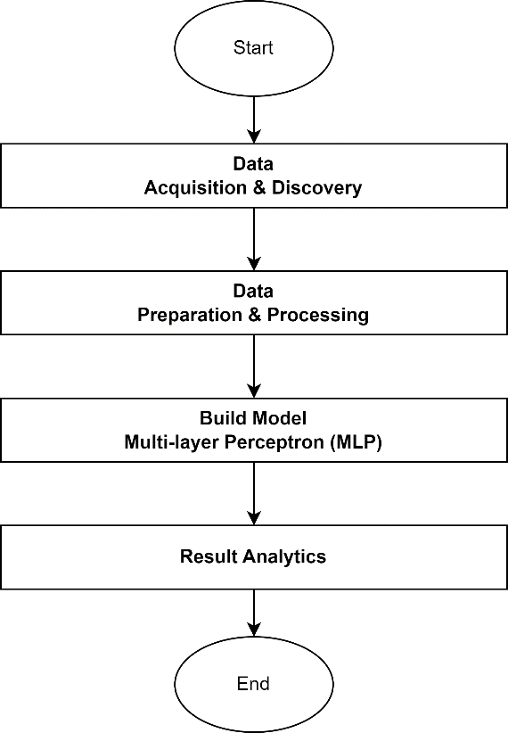

**Figure 4.1 Flowchart**

Algorithm:

1. Data Loading and Exploration
   1. read dataset by using ‘read.csv’ function.
   2. examined the structure of dataset using ‘glimpse’ function.
   3. visualize the initial data using ‘ggplot2’ function.
2. Data Cleaning
   1. remove outliers using z-scores.
3. Data Splitting
   1. split the dataset into training and testing sets.
   2. 70% of the data is used for training and 30% is for testing.
4. Scaling and Normalization
   1. scale the training and testing data set.
   2. min max normalization is applied to the data set.
5. Neural Network Model Building
   1. create a sequential keras model.
   2. dense layers with various units and activation functions are added.
   3. comply the model with Adam optimizer and Mean Absolute Error (MAE) loss.
   4. display summary model.
6. Training Model
   1. the model is trained on the training data set with 50 epochs.
   2. use variable ‘history’ to store the training history.
7. Prediction and Evaluation
   1. use test data set to make predictions.
   2. round the predictions to integers.
   3. use confusion matrix to evaluate model.
8. Performance Metrics Calculation
   1. calculate accuracy, recall, precision, and f1-score from confusion matrix.
9. Results Printing
   1. print the calculated performance in 8.1.

Problem Solving:

1. Understanding the problem
2. Define the problem clearly which is engine condition classification based on attributes.
3. Understand each attribute in the dataset.
4. Data Exploration
5. Decide which function in R to understand its structures and features.
6. Identify the potential weakness such as missing data or outliers.
7. Data Cleaning and Preprocessing
8. Replace or remove the missing value if present.
9. Decide the technique such as outlier removal to ensure the quality of dataset.
10. Scaling and Normalization
11. Decide which scaling and normalization techniques want to be applied.
12. Model Selection
13. Choose a suitable neural networks architecture for the project.
14. Consider the number of layers, unit and activation function.
15. Model Evaluation
16. Evaluate the model’s performance using metrics such as accuracy, recall, precision, and F1-score.
17. Visualize the performance using graph.
18. Analyze the confusion matrix to understand false positives and false negatives.
19. Improvement
20. Adjusting hyperparameters such as learning rate or number of layers.
21. Exploring different neural networks architecture.
22. Choose another Scaling and normalization method.
23. Communication
24. Effectively communicate the whole decision to stakeholder or project members.
25. **Project Implementation and Output**

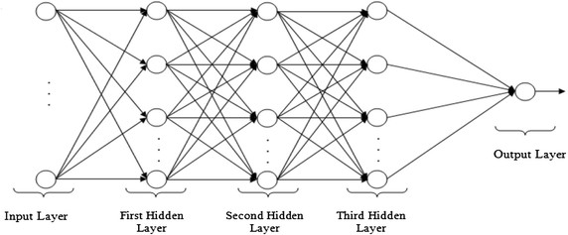

**Figure 5.1 Neural Network Model (MLP)**

Multi-Layer Perceptron (MLP) neural network. Using the keras_model_sequential function from the Keras library, we created a Feedforward model. This allowed us to add layers to the model sequentially. Our MLP architecture consisted of multiple dense layers (1 input layer, 3 hidden layers, 1 output layer), each with a different activation function and a specified number of neurons. We then compiled the model by specifying an optimizer (e.g., Adam), a loss function (e.g., mean absolute error), and other relevant metrics. The model was trained using the fit function, which involved iteratively adjusting the model's weights and biases using the backpropagation algorithm.

|  |  |
| --- | --- |
| Training size | 70% |
| Testing size | 30% |
| Optimizer | Adam |

**Table 5.1 Ratio for training and testing data set**

|  |  |  |  |  |  |
| --- | --- | --- | --- | --- | --- |
|  | Input layer | First hidden layer | Second hidden layer | Third hidden layer | Output layer |
| Activation Function | - | ReLU | ReLU | Sigmoid | - |
| Nodes of layers | 128 | 128 | 64 | 32 | 1 |

**Table 5.2 Activation function and number of nodes for each layer**

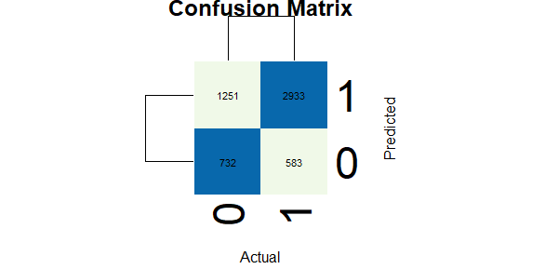

0 represent bad condition.

1 represent good condition.

**Figure 5.2 Confusion Matrix**

True Positives (TP): This refers to the number of instances where the model predicted the positive class correctly. In this case, the positive class represent an engine in bad condition. In the confusion matrix, the value in the bottom-left corner (732) represents the number of true positives.

False Positives (FP): This indicates the number of instances where the model predicted the positive class incorrectly. It means the model predicted an engine to be in bad condition, but it was actually in good condition. In the confusion matrix, the value in the bottom-right corner (583) represents the number of false positives.

True Negatives (TN): These are the instances where the model predicted the negative class correctly. It means the model correctly identified that the engine in good condition. In the confusion matrix, the value in the top-right corner (2933) represents the number of true negatives.

False Negatives (FN): This refers to the instances where the model predicted the negative class incorrectly. It means the model failed to identify an actual engine condition. In the confusion matrix, the value in the top-left corner (1251) represents the number of false negatives.

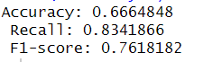

**Figure 5.3 Performance Metrics**

The accuracy of the model is 0.6664848, which means that approximately 66.65% of the predictions made by the model are correct. This metric measures the overall correctness of the model's predictions.

The recall (also known as sensitivity or true positive rate) is 0.8341866, indicating that the model is able to correctly identify approximately 83.41% of the actual positive instances. In the context of automotive vehicle engine health prediction, this means that the model is successful in capturing a high proportion of engine failures.

The F1-score is 0.7618182, which is a balanced measure of precision and recall. It takes into account both the ability of the model to correctly identify positive instances (precision) and its ability to capture all positive instances (recall). A higher F1-score indicates a better overall performance of the model.

In summary, the provided evaluation metrics suggest that the model has moderate accuracy, successfully captures a significant proportion of engine failures (high recall), and provides a reasonably balanced measure of precision and recall (moderate F1-score). However, it is important to consider the specific requirements and context of the automotive vehicle engine health prediction problem to determine whether these performance metrics meet the desired level of accuracy and reliability for the intended application.

1. **Conclusion**

In conclusion, the development of Predictive Maintenance Software for the automotive industry represents a significant advancement in addressing issues related to vehicle breakdowns and repair costs. Leveraging machine learning models, particularly neural networks, has enabled a proactive approach to vehicle health management by analyzing sensor data. This software aims to predict potential problems or failures in various vehicle components, leading to preventive maintenance strategies.

The software's key features encompass data acquisition, preprocessing, and cleaning, utilizing machine learning models for analysis, real-time alerts and notifications, as well as a comprehensive dashboard and reporting system. Integration capabilities with existing vehicle administration systems, scalability, and performance optimization are crucial aspects, ensuring efficient handling of sensor data for various vehicle models.

The software's technological foundation includes programming languages for data analysis, data processing libraries for manipulation and preprocessing, backend frameworks for constructing APIs, and databases for storing sensor data. Deployment is facilitated through containerization, orchestration, and cloud platforms.

User interaction is facilitated through a user-friendly dashboard and API endpoints, enhancing the software's versatility and integration capabilities. Security and privacy measures, including data encryption and access control, safeguard sensitive information.

The AIPM (Automated Information Processing Model) details the initiation, planning, execution, monitoring, controlling, and closing processes of the project. Key components include project objectives definition, business case, stakeholder identification, risk assessment, project kickoff meeting, scope definition, work breakdown structure creation, task scheduling, resource planning, risk management, budgeting, quality assurance, communication plan, dataset acquisition, data preprocessing, model development, training and validation, model performance assessment, iterative improvement strategies, progress tracking, quality assurance measures, risk management, comprehensive documentation, knowledge transfer sessions, project review, and lessons learned.

In summary, the Predictive Maintenance Software, supported by the AIPM framework, not only addresses technical aspects of data analysis and machine learning but also incorporates robust project management processes. The emphasis on documentation, knowledge transfer, and continuous improvement reflects a commitment to delivering high-quality solutions while meeting industry standards and regulations. This holistic approach ensures the software's effectiveness, reliability, and adaptability for the automotive industry's evolving needs.

1. **References**
2. Jayrdixit. (2023, September 25). *Automotive Vehicles Engine Health analysis*. Kaggle. <https://www.kaggle.com/code/jayrdixit/automotive-vehicles-engine-health-analysis>
3. *Smart Vehicle: Online prognosis for vehicle health monitoring*. (2020). <https://www.indianjournals.com/ijor.aspx?target=ijor:jicse&volume=9&issue=2&article=003>
4. Khoshkangini, R., Mashhadi, P. S., Berck, P., Shahbandi, S. G., Pashami, S., Nowaczyk, S., & Niklasson, T. (2020). Early prediction of quality issues in automotive modern industry. *Information*, *11*(7), 354. <https://doi.org/10.3390/info11070354>
5. Shafi, U., Safi, A., Raza, B., Ziauddin, S., & Saleem, M. Q. (2018). Vehicle Remote Health Monitoring and Prognostic Maintenance System. *Journal of Advanced Transportation*, *2018*, 1–10. <https://doi.org/10.1155/2018/8061514>
6. Consequence analysis in Predictive health monitoring of automotive diesel engine defects on JSTOR. (n.d.). *www.jstor.org*. <https://www.jstor.org/stable/26277716>
7. *Predictive maintenance for the automotive industry*. (2023, October 4). Advanced PCB Design Blog | Cadence. <https://resources.pcb.cadence.com/blog/2023-predictive-maintenance-for-the-automotive-industry>
8. Mukherjee, S., Varde, A. S., Javidi, G., & Sheyban, E. (2014). Predictive analysis of engine health for decision support. *SIGKDD Explorations*, *15*(2), 39–49. <https://doi.org/10.1145/2641190.2641197>
9. Sharma, D. (2022, July 22). *Application of AI in predictive maintenance of vehicles*. Analytics Vidhya. <https://www.analyticsvidhya.com/blog/2022/07/application-of-ai-in-predictive-maintenance-of-vehicles/>
10. Cerebrumx, & Cerebrumx. (2022, June 24). Vehicle data enables thoughtful predictive maintenance by unlocking malfunction sensor Info - CerebrumX. *CerebrumX -*. <https://cerebrumx.ai/vehicle-data-enables-thoughtful-predictive-maintenance-by-unlocking-malfunction-sensor-info/>
11. Vasavi, S., Aswarth, K., Pavan, T. S. D., & Gokhale, A. A. (2021). Predictive analytics as a service for vehicle health monitoring using edge computing and AK-NN algorithm. *Materials Today: Proceedings*, *46*, 8645–8654. <https://doi.org/10.1016/j.matpr.2021.03.658>
    1. **Appendices**

Figure 3.1.1 Gantt Chart of the Project

Figure 4.1 Flowchart   
Figure 5.1 Neural Network Model ( MLP)  
Figure 5.2 Confusion Matrix  
Figure 3.5.1 Customer Acceptance Form  
Figure 3.5.2 Lessons Learned Document

Figure 3.5.3 Close Contract

Table 3.1.1 Project Charter  
Table 3.1.2 Stakeholders Analysis

Table 3.1.3 Work Breakdown Structure  
Table 3.1.4 SWOT Analysis  
Table 3.1.5 Automotive Vehicles Engine Health Prediction Project Cost Estimate  
Table 3.1.6 Automotive Vehicles Engine Health Prediction Project Development Estimate

Table 5.1 Ratio for training and testing data set

Table 5.2 Activation function and number of nodes for each layer